**Change Management (Final Project)**

**By**

**Kavitha Ranganathan (kavitharanga@gmail.com)**

Change Management is a system for tracking and processing changes. ITIL classifies changes into 2 main broad categories, Change and Service. Change requests can be further broken down in to Standard, Normal and Complex.

In this project I have mainly concentrated on creation of a Standard Change Request and its fulfillment.

Once you have the project installed and running in IntelliJ, the application can be started by going to

<http://localhost:8080/changeRequest/index.html>

I have loaded one request by default and it will be displayed on the index page. A new Change request can be created by clicking on the Create New Request link. Upon clicking it will present you with a screen like this

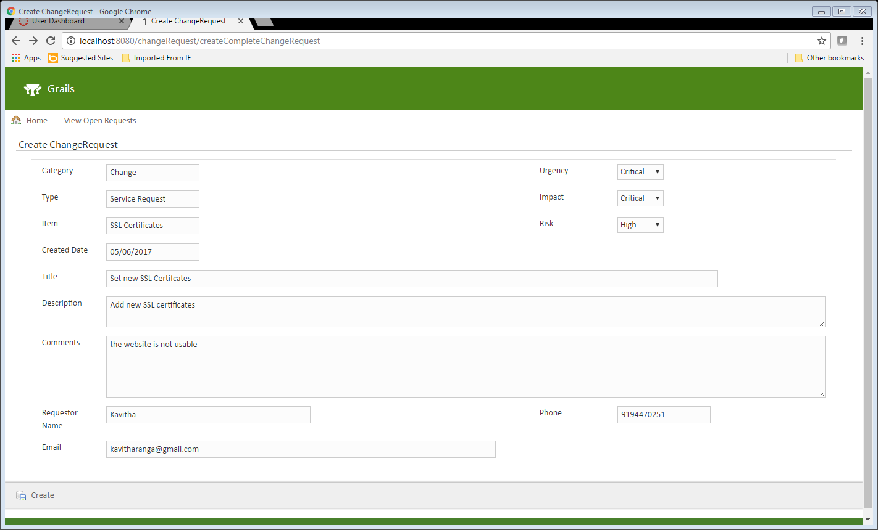

Upon clicking the Create button the request will be created and the below confirmation screen with the details will be displayed.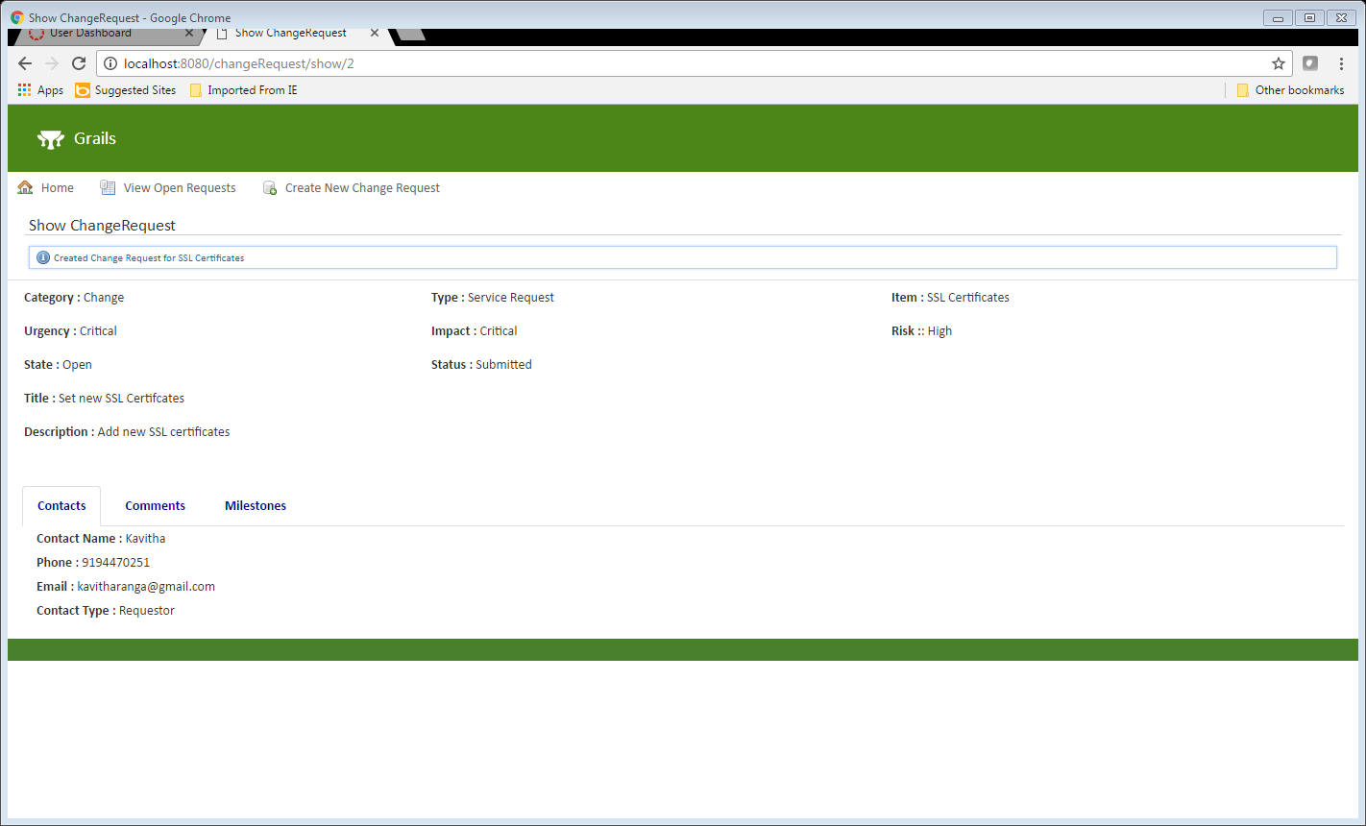

The comments tab will show the comments the user entered. Milestones are calculated for the change type and automatically added once a phase is completed.

All Open requests can be viewed by clicking the View Open Requests link and once the requests are closed they can be viewed under View Closed Requests link.

Upon clicking a request from the Open Requests link, it will present with a fulfillment screen where the requests can be progressed from

Submit-----In Review ----Scheduled-----In Progress ---- Completed

1. Screen for Accepting the request that will move the request to “In Review” status

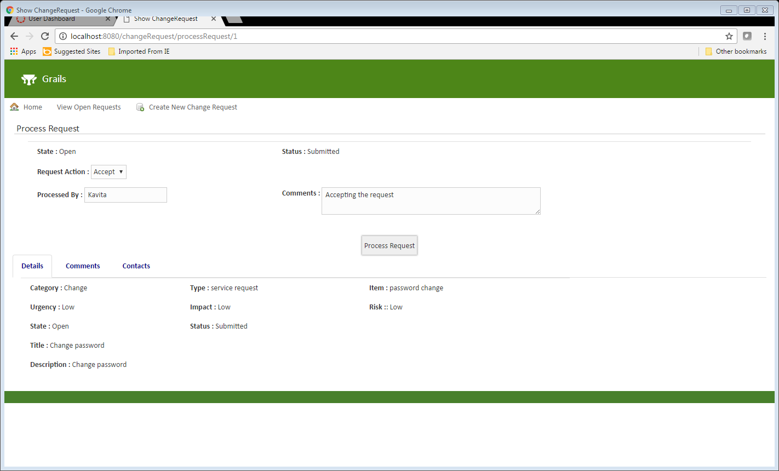

1. Upon clicking the Process Request, the status of the request will change to “In Review” and the request action dropdown will show the allowed set of actions

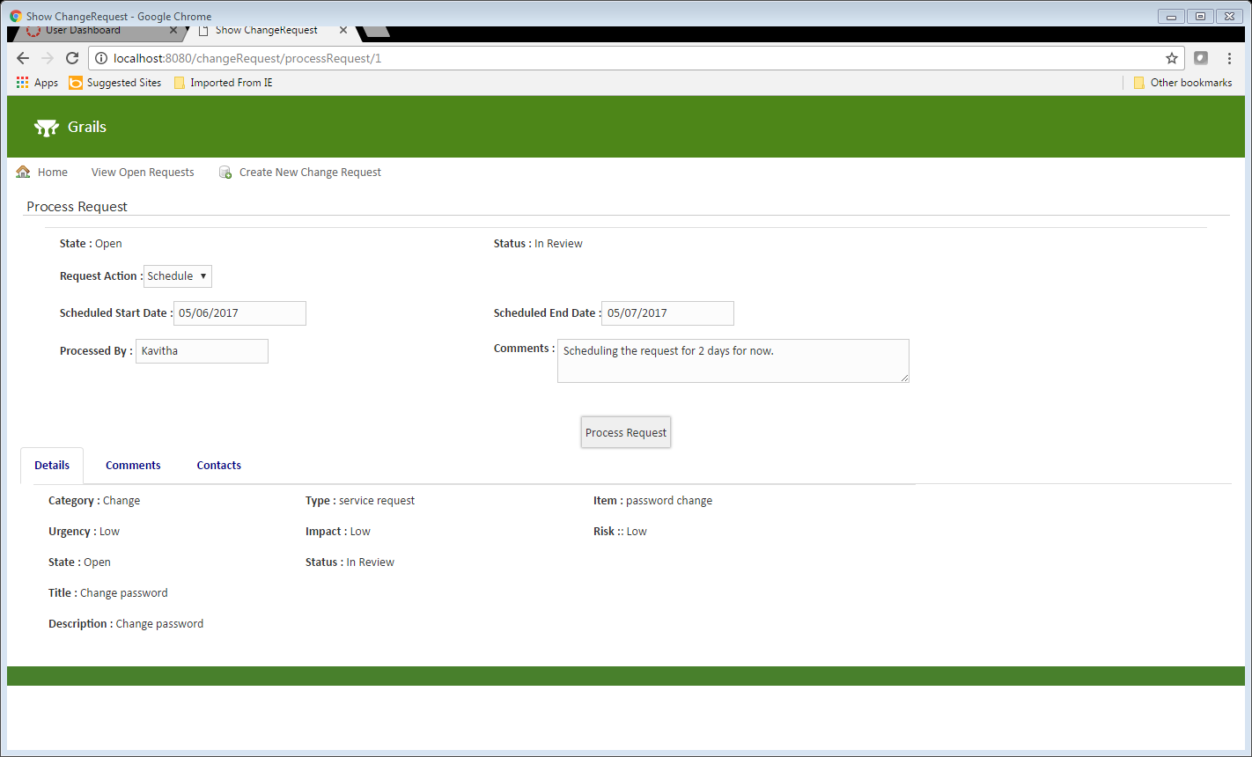

The request can now be scheduled with the provision to enter the scheduled dates. Upon clicking the process request button the request status will change to Scheduled and the scheduled dates will be stored.

1. Once the request is scheduled, it is ready for Implementation. The scheduled dates entered during Schedule Request action are displayed and if need be can be changed further here until the implementation is completed.

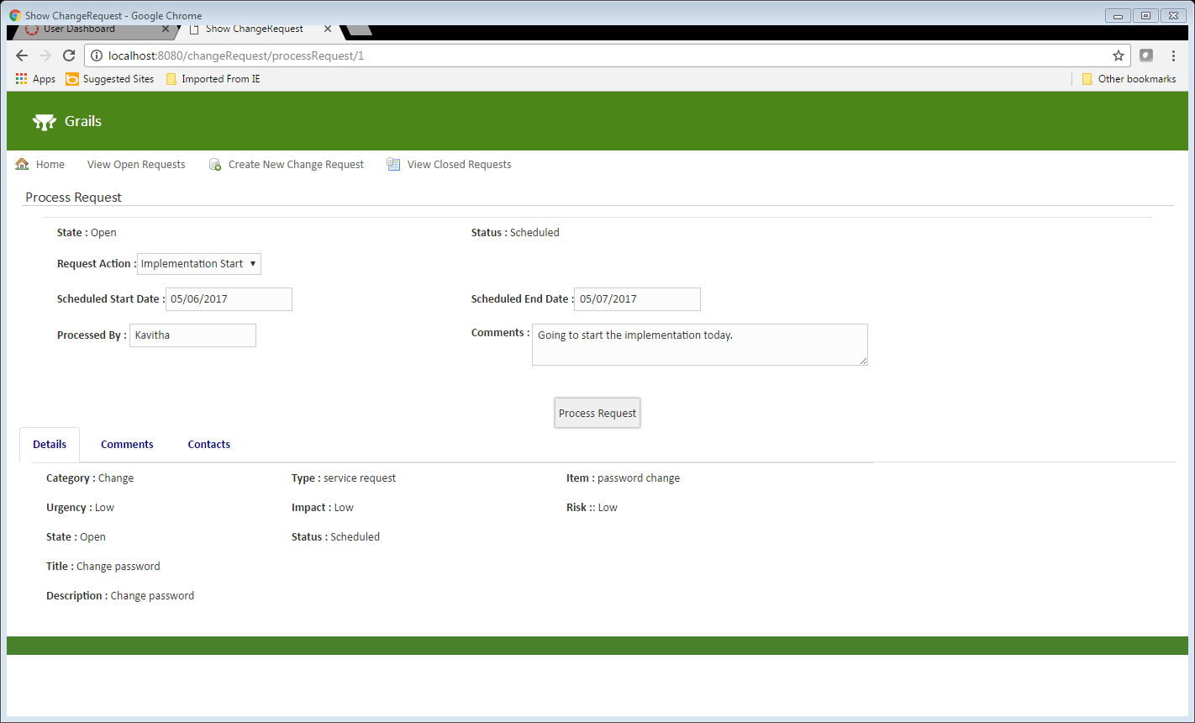

1. Once the Implementation Completed is selected, the request will be closed completed.

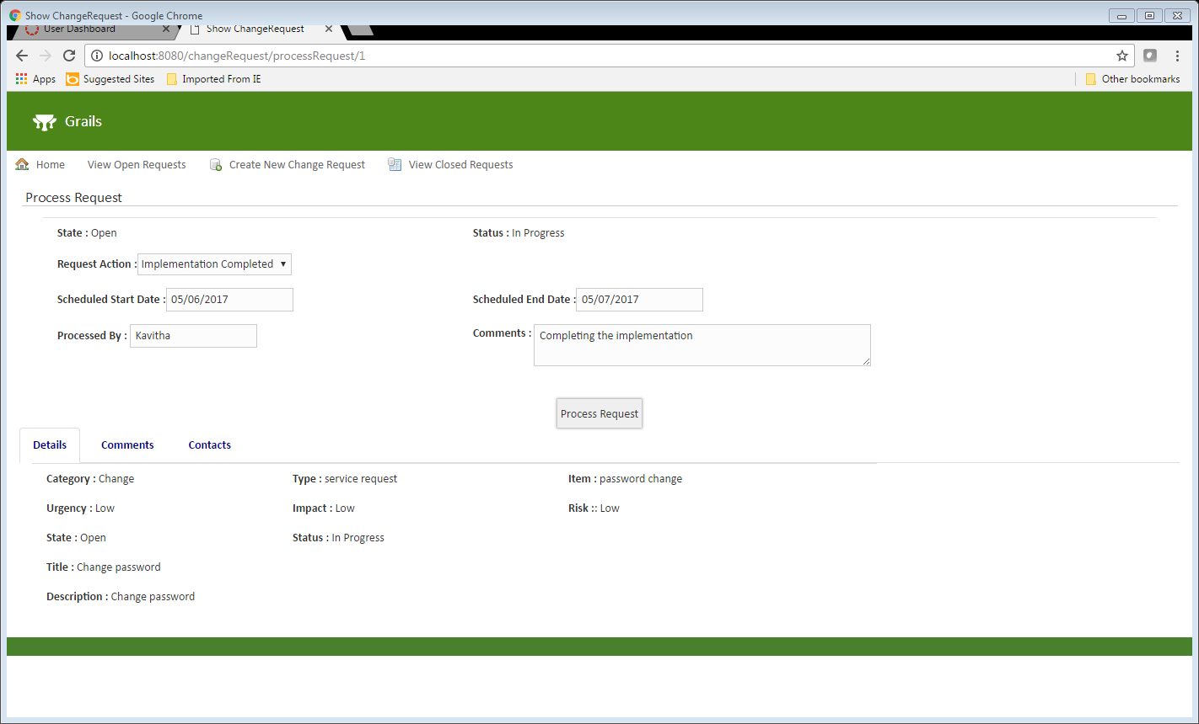

The request has now moved from Open Requests to Closed requests and the Closed Requests link will display the request as shown below

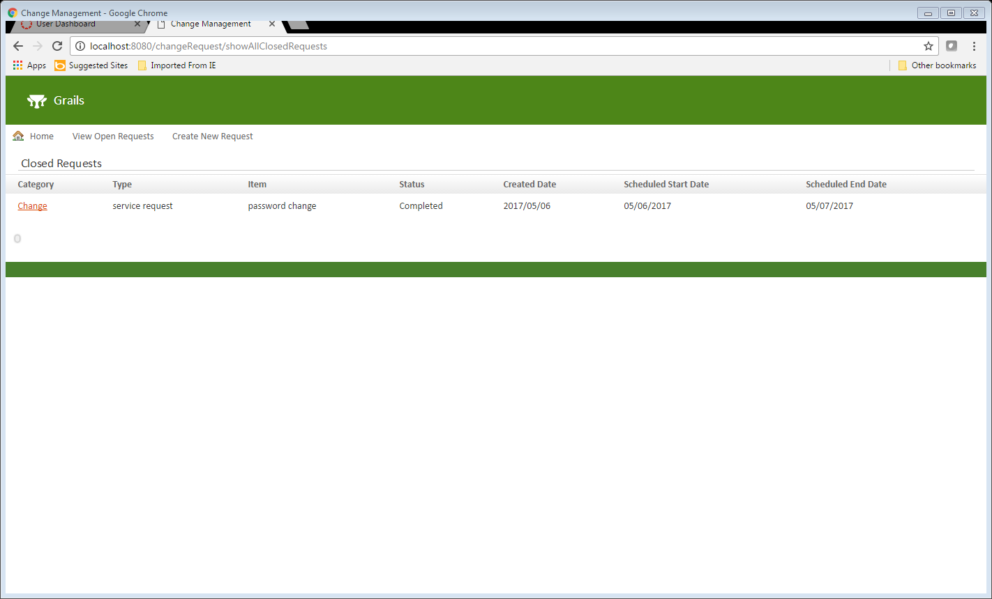

All the comments entered on the request can be viewed under the comments tab of the request

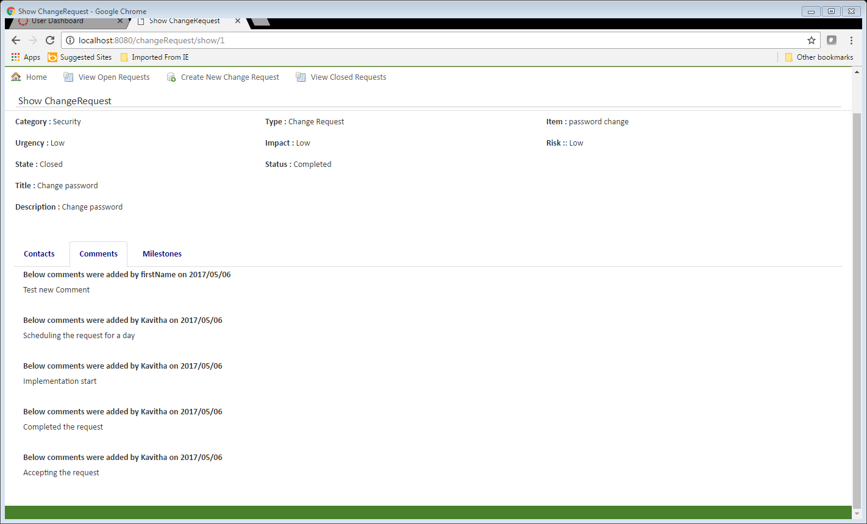

The Milestones can be viewed under the Milestones tab as shown below

